Contents
Core Problem a Service Mesh Solves 1
Sidecar Proxy and Its Role 1
Kubernetes Ingress vs Istio Ingress Gateway 2
Observations from the Kiali Service Graph 2
VirtualService vs DestinationRule 2
Progression from Labs 05 to 08 3
Screenshots 3

Core Problem a Service Mesh Solves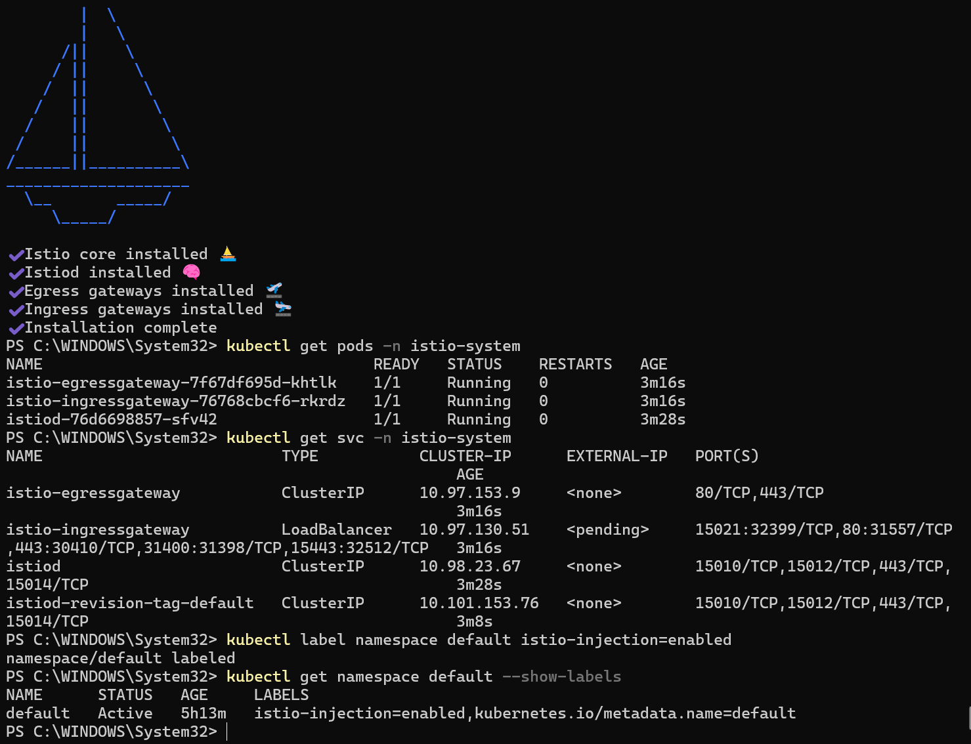
A service mesh solves the problem of managing communication between microservices in a distributed system. While Kubernetes handles container orchestration (deployment, scaling, and availability), it does not provide advanced control over how services communicate with each other.
In a production environment with many microservices, issues such as lack of visibility, unencrypted communication, no retry or failure handling, and limited traffic control become critical. Kubernetes alone cannot track request flows, enforce security between services, or manage fine-grained routing.
A service mesh like Istio adds a dedicated infrastructure layer that manages all service-to-service communication, enabling observability, security, reliability, and advanced traffic routing without modifying application code.

Sidecar Proxy and Its Role
A sidecar proxy is a lightweight container (Envoy in Istio) that runs alongside each application container within the same Pod. It intercepts all incoming and outgoing network traffic for that service.
The sidecar handles tasks such as traffic routing, encryption (mTLS), logging, and monitoring. This allows these features to be implemented externally rather than inside the application itself.
The sidecar was confirmed to be successfully injected when running:
kubectl get pods
All Pods showed READY 2/2, indicating two containers per Pod (application and sidecar proxy). This verified that Istio’s automatic sidecar injection was working correctly.

Kubernetes Ingress vs Istio Ingress Gateway
A Kubernetes Ingress provides basic HTTP and HTTPS routing to services from outside the cluster. It mainly operates at Layer 7 but has limited flexibility and requires external controllers for advanced features.
In contrast, the Istio Ingress Gateway is a fully integrated component of the service mesh that provides advanced traffic management capabilities. It supports fine-grained routing rules, traffic splitting, retries, timeouts, and security policies.
The Istio Gateway works together with VirtualService resources to control traffic behavior in detail, making it far more powerful and flexible than standard Kubernetes Ingress.

Observations from the Kiali Service Graph
The Kiali dashboard displayed a real-time service topology of the Bookinfo application, showing how all services (productpage, details, reviews, and ratings) communicate with each other.
It provided visual information such as request flow between services, traffic volume and request rates, response times and latency, error rates, and the health status of each service.
This level of observability is not available using kubectl alone, which only shows resource states such as Pods and Services, but not live traffic behavior or relationships between services.

VirtualService vs DestinationRule
A DestinationRule defines policies and subsets such as v1, v2, and v3 for a service. It tells Istio how to treat traffic once it reaches a service, including version grouping and load balancing behavior.
A VirtualService defines how traffic is routed to those subsets. It controls which version of a service receives requests and under what conditions.
In Task E, the traffic-splitting rule used a VirtualService to send 50 percent of traffic to reviews v1 and 50 percent to reviews v3.
This was achieved using weighted routing. When the page was refreshed multiple times, different versions were served, confirming the split.
This represents a canary deployment, a real-world strategy where a new version is gradually introduced to a subset of users to test stability before full rollout.

Progression from Labs 05 to 08
Across Labs 05 to 08, there is a clear progression from simple container usage to a production-ready cloud-native architecture.
Lab 05 focused on running a single container locally and understanding basic containerisation.
Lab 06 introduced managing multiple containers along with networking and lifecycle operations.
Lab 07 focused on Kubernetes orchestration, including scaling, self-healing, and load balancing.
Lab 08 introduced Istio as a service mesh, adding observability, security, and advanced traffic control between services.

Screenshots
A)


B)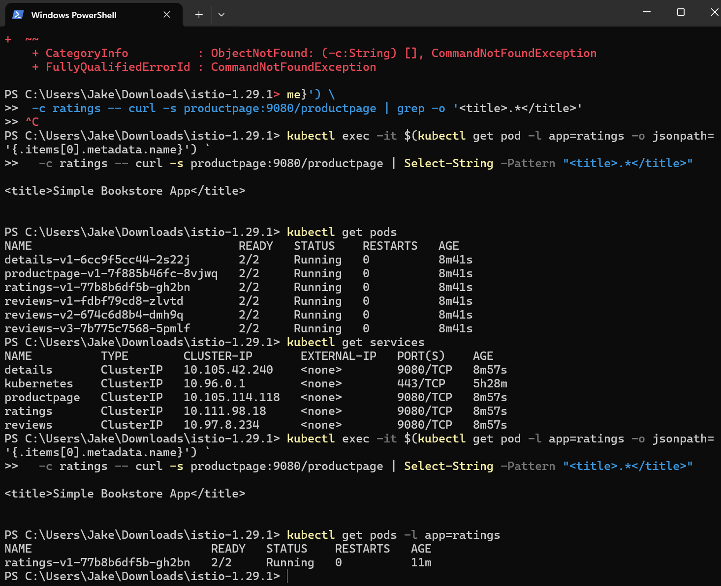

C)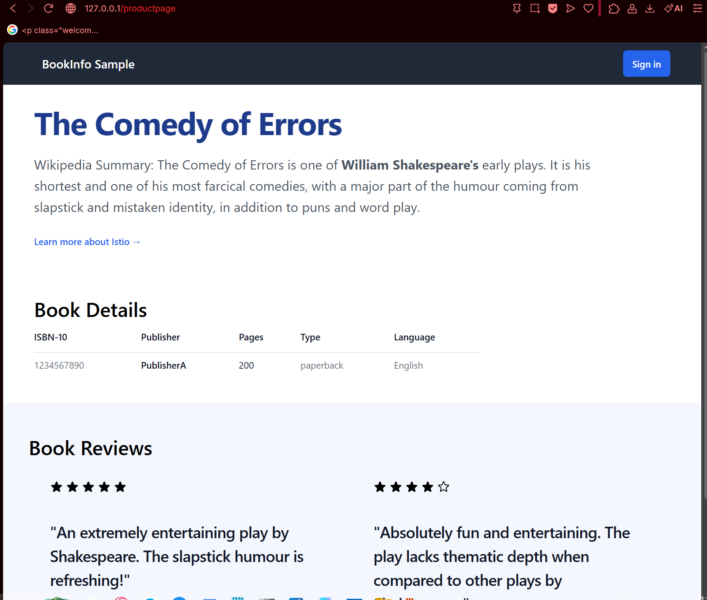

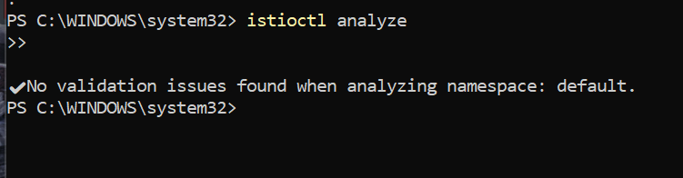

D)
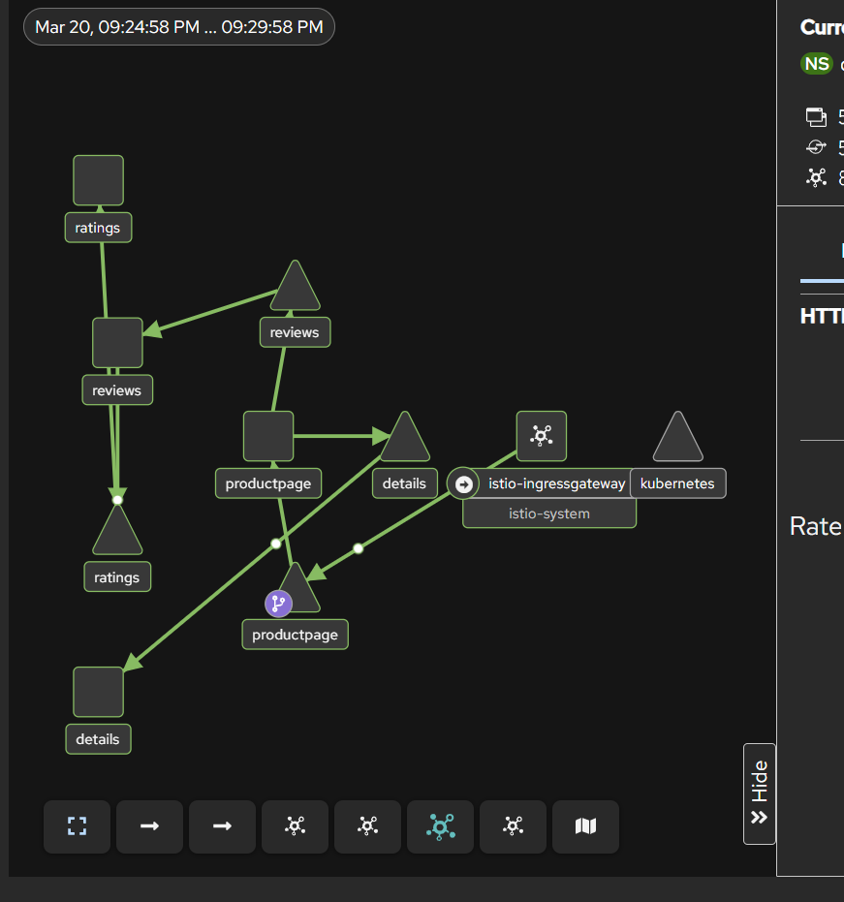
E) 